Test Case: tc006_SPX_Dev5_Crear_Requisicion_Spot_Tipo_Cobro_Proyect_Urgent
Step 1 - Enter username and password and click to button Enter: Credentials Entered
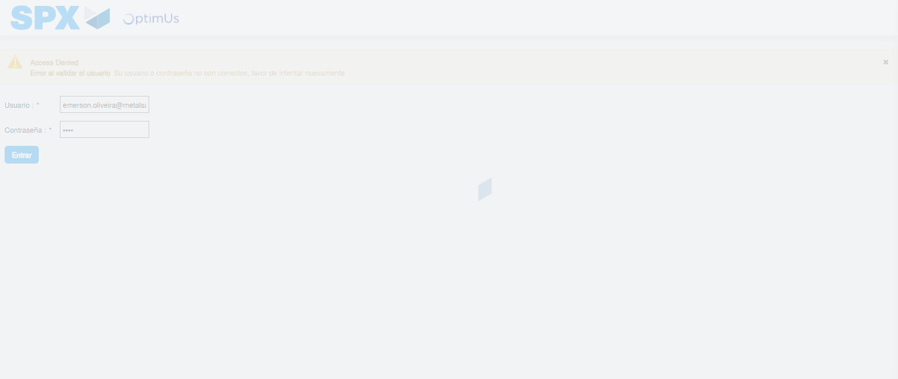Image file-name: QC_Testing-tc006_SPX_Dev5_Crear_Requisicion_Spot_Tipo_Cobro_Proyect_Urgent-1787008542867

Step 2 - Select to UEN and Access to Spot Buy Requisitions : UEN Correctly selected and Correct access
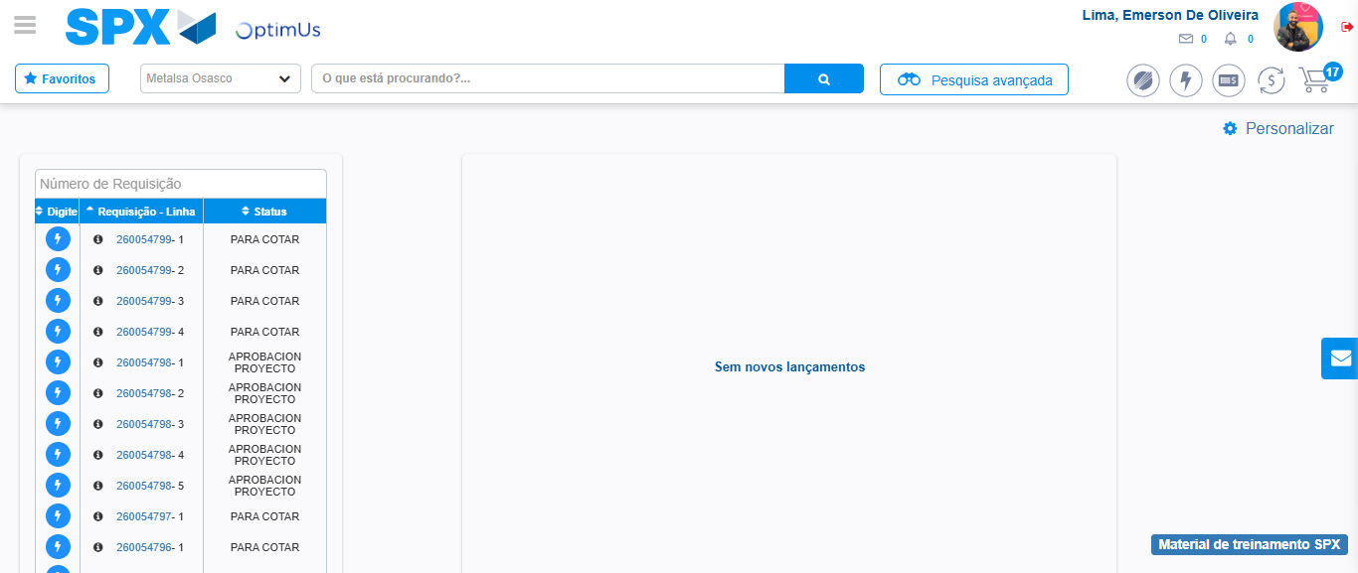Image file-name: QC_Testing-tc006_SPX_Dev5_Crear_Requisicion_Spot_Tipo_Cobro_Proyect_Urgent-1787008630668

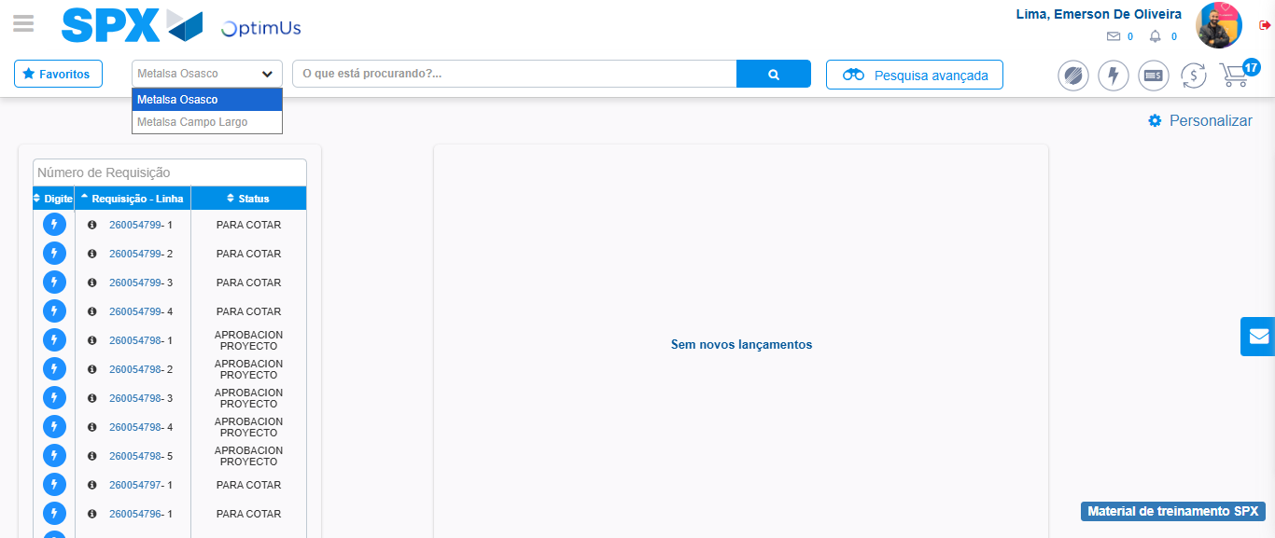Image file-name: QC_Testing-tc006_SPX_Dev5_Crear_Requisicion_Spot_Tipo_Cobro_Proyect_Urgent-1787008633416

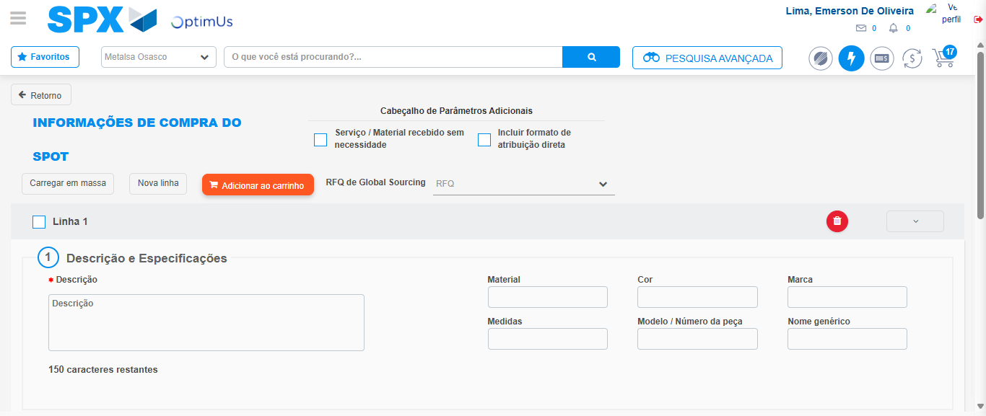Image file-name: QC_Testing-tc006_SPX_Dev5_Crear_Requisicion_Spot_Tipo_Cobro_Proyect_Urgent-1787008644837

Step 3 - Data Capture Spot Buy Requisition: Data captured correctly
Image file-name: QC_Testing-tc006_SPX_Dev5_Crear_Requisicion_Spot_Tipo_Cobro_Proyect_Urgent-1787008645158

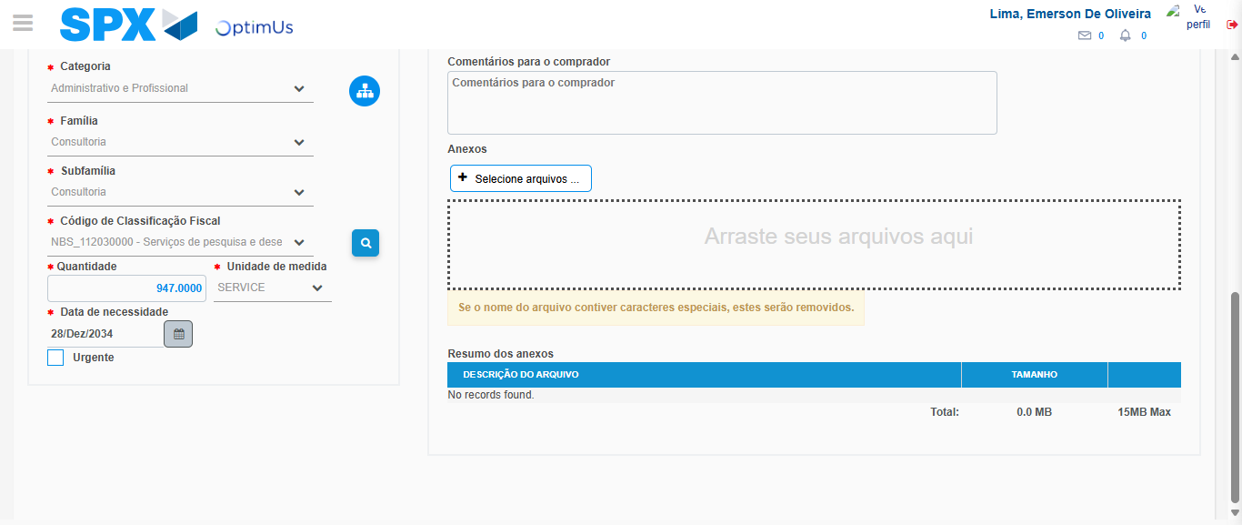Image file-name: QC_Testing-tc006_SPX_Dev5_Crear_Requisicion_Spot_Tipo_Cobro_Proyect_Urgent-1787008662375

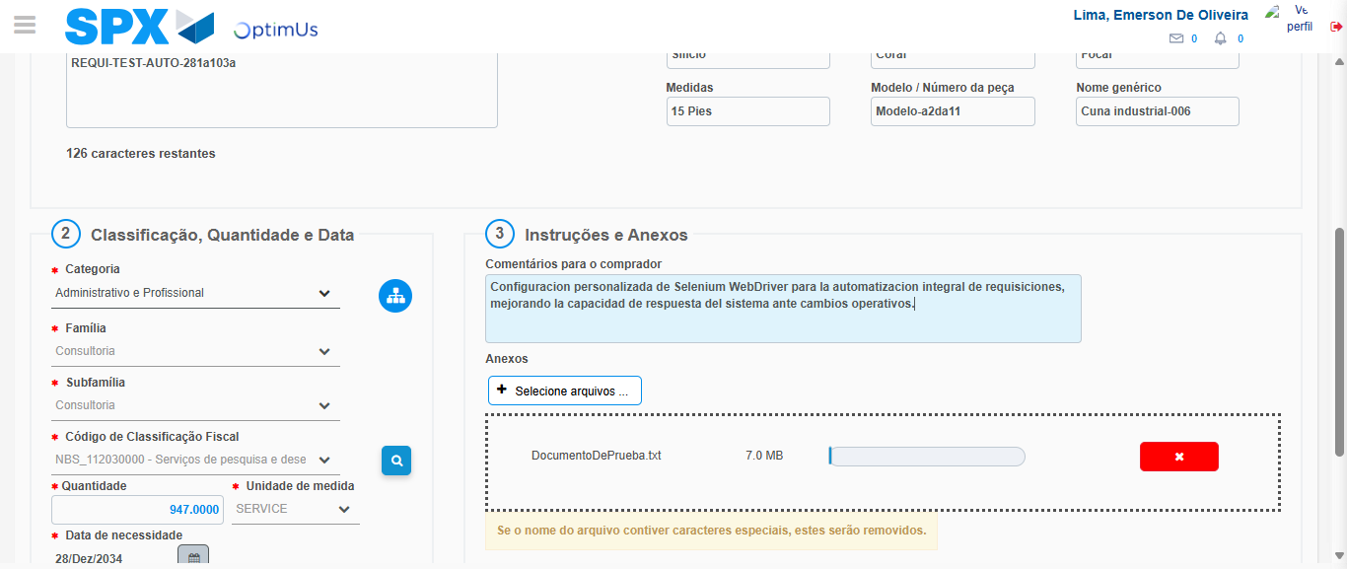Image file-name: QC_Testing-tc006_SPX_Dev5_Crear_Requisicion_Spot_Tipo_Cobro_Proyect_Urgent-1787008663269

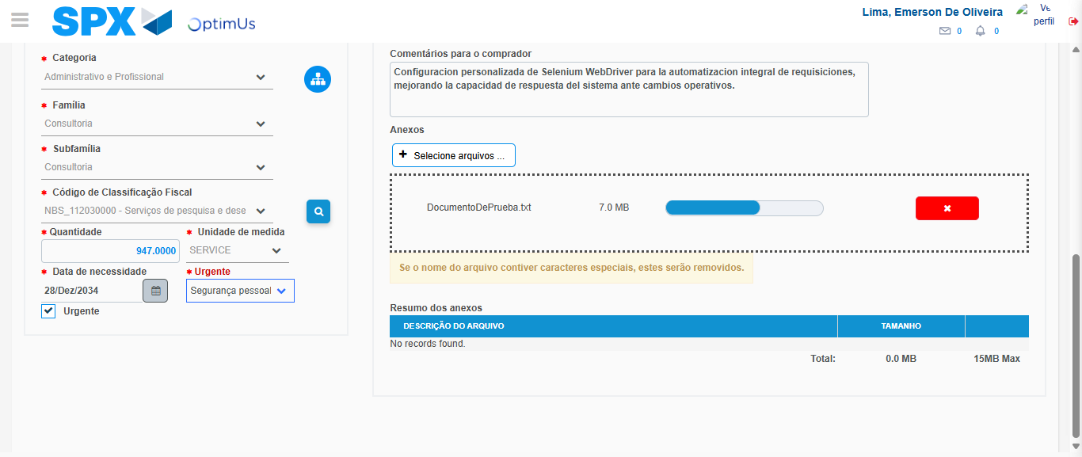Image file-name: QC_Testing-tc006_SPX_Dev5_Crear_Requisicion_Spot_Tipo_Cobro_Proyect_Urgent-1787008667236

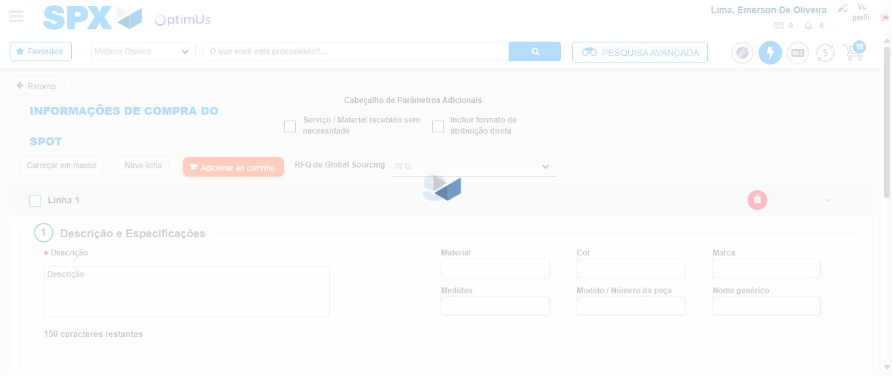Image file-name: QC_Testing-tc006_SPX_Dev5_Crear_Requisicion_Spot_Tipo_Cobro_Proyect_Urgent-1787008669345

Step 7 - Return to Main Page SPX : Return to Main Page SPX
Image file-name: QC_Testing-tc006_SPX_Dev5_Crear_Requisicion_Spot_Tipo_Cobro_Proyect_Urgent-1787008630668

Image file-name: QC_Testing-tc006_SPX_Dev5_Crear_Requisicion_Spot_Tipo_Cobro_Proyect_Urgent-1787008633416

Image file-name: QC_Testing-tc006_SPX_Dev5_Crear_Requisicion_Spot_Tipo_Cobro_Proyect_Urgent-1787008644837

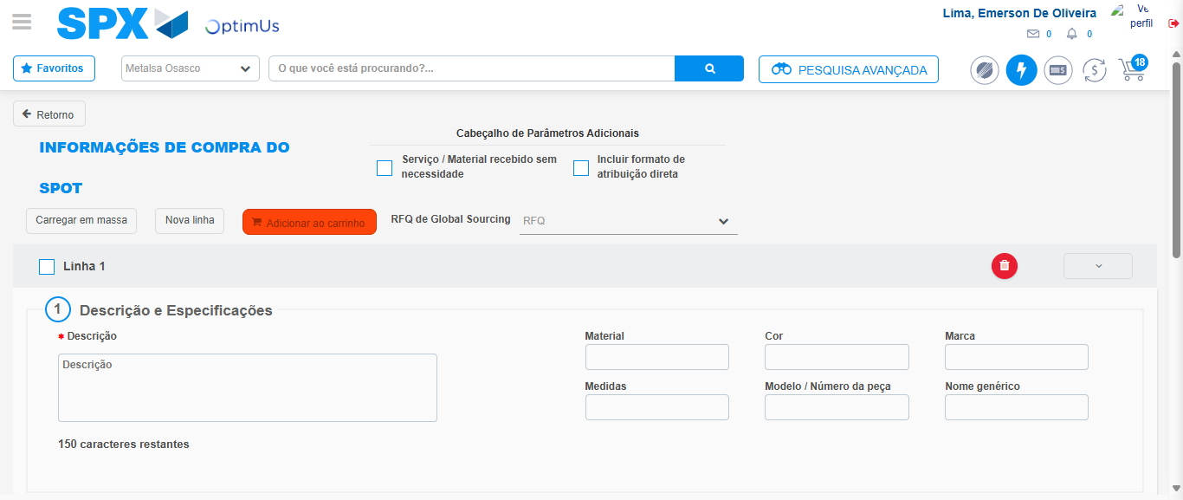Image file-name: QC_Testing-tc006_SPX_Dev5_Crear_Requisicion_Spot_Tipo_Cobro_Proyect_Urgent-1787008671621

Image file-name: QC_Testing-tc006_SPX_Dev5_Crear_Requisicion_Spot_Tipo_Cobro_Proyect_Urgent-1787008671826

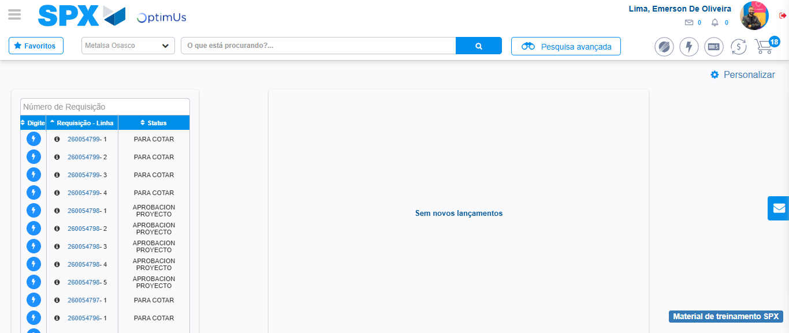Image file-name: QC_Testing-tc006_SPX_Dev5_Crear_Requisicion_Spot_Tipo_Cobro_Proyect_Urgent-1787008693014

Step 8 - Log Out : Log Out SPX
Image file-name: QC_Testing-tc006_SPX_Dev5_Crear_Requisicion_Spot_Tipo_Cobro_Proyect_Urgent-1787008693241

